**OLTP Systems Models:**

**Schema 1:**

Analyzed entities:

Coin_market :

|  |
| --- |
| Id |
| Symbol |
| Image |
| Current_value |
| Market_cap |
| Market_rank |
| Total_volume |
| High_24h |
| **Low_24h** |
| **Price_change_24h** |
| Price_change_percent_24h |
| market_cap_change_24h |
| Market_cap_change_percent_24h |
| **Ath** |
| **Ath_change** |
| Ath_change_percent |
| Ath_date |
| Last_updated |

**Coins:**

|  |
| --- |
| Id |
| Symbol |
| name |

**Asset_platforms:**

|  |
| --- |
| **Id** |
| **Chain_identifier** |
| **Name** |
| **Short_name** |

**Exchanges:**

|  |
| --- |
| **Id** |
| **Name** |
| **Year_established** |
| **Country** |
| **Description** |
| **url** |
| **Image** |
| **Has_trading_incentive** |
| **Trust_score** |
| **Trust_rank** |
| **Trade_volume** |

**Categories:**

|  |
| --- |
| **Id** |
| **name** |

**Categories_list**

|  |
| --- |
| **Id** |
| **Name** |
| **Market_cap_change** |
| **Volume_24h** |
| **Market_cap** |
| **Update_date** |

**Derivative_exchange_list:**

|  |
| --- |
| **Id** |
| **name** |

**Derivatives:**

|  |
| --- |
| **Market** |
| **Symbol** |
| **Index_id** |
| **Price** |
| **Index** |
| **volume** |

**----------------------------------------------------------------------------------------------------------------------------------------**

**Crypto Trading Schema:**

**Entities Definitions:**

1. **Coins – we have described about list of all the coins with id and symbol**
2. **Category – in this entities, we can define each category type and details, for example what type of coin it will be : like crypto / index etc**
3. **Coin_category – in this entity we will define coins under each category coin associated with category**
4. **Exchange_type – in this definition it will have details about what type of exchange it is! Ex: spot, derivative etc.**
5. **Exchange – this entity is about spot exchange details and market value/cap it have ex: coinbase,binance etc**
6. **Derivatives – this definition is on derivative exchange details and symbol,market value,volume etc ex: indexes , btcech etc**
7. **Market – this table will hold daily trading data of each coin ,collected on daily basis with date and volume and current price etc.**
8. **Coin_exchange – this definition is about coins listed on spot exchanges ex: coins under coinbase ,binance etc**

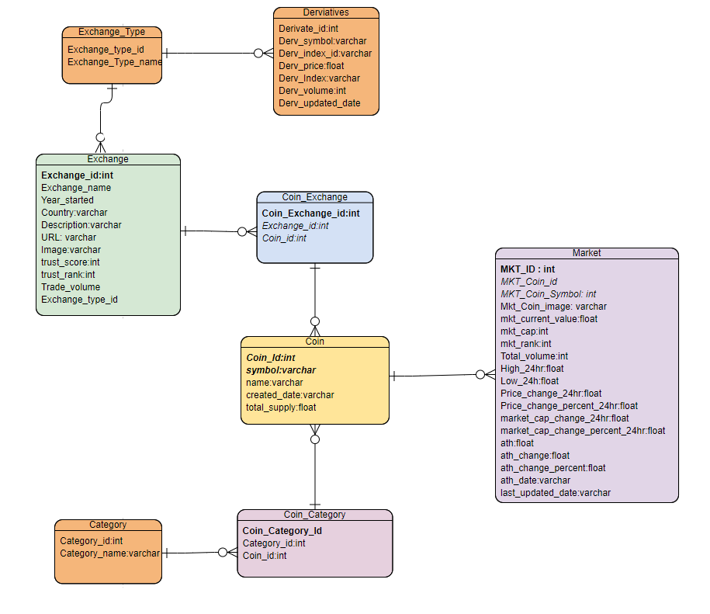

**Schema 2:**

**Entities Definition:**

1. **User – will contain details about user credentials and communication details**
2. **PopularCoins – this table will contain few top listed coins on daily basis and these details will be extracted from main schema**
3. **Portfolio – this table will contains coins selected by user from popular coins table, this selected list will be highlighted on portfolio of user with few extra details like current market cap and volume.**

